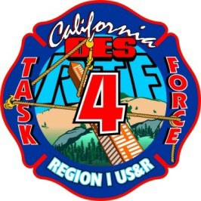
US&R REGIONAL TASK FORCE 4

Advance Team Checklist

PERSONNEL

Advance team make-up is not and cannot be a one-size fits all team. The TFL has ultimate authority on the make-up of the advanced team based on incident needs, team needs, and input from managers.

Determination Considerations

Established incident or immediate need response?

Incident check-in expectations?

IMT in place and operational?

USAR Branch established?

Staging area at incident identified?

Need for immediate action/operations upon arrival to incident?

Is team checking-in and reporting for next Ops period?

PLANNED NEED INCIDENTS

WHO IS NEEDED for Check-In and pre-operational planning & needs? This decision will be based off of incident & IMT expectations, briefings, SIT-STAT, Etc.

TFL?

PTM?

TIS?

Safety?

RM

SM?

IMMEDIATE NEED RESPONSES (Team is expected to respond directly to operational assignment)
- MPK personnel with Base of Operations (BoO)
- RECON personnel
  - TFL (based on situation & Incident priorities) *TFL decision
  - ASO (based on situation & Incident priorities) *TFL decision
  - Planning Team Manager
  - Search Manager
  - Rescue Manager
  - Haz-Mat Specialist

ENROUTE
- Comm Plan
- Report back to RTF-4 on road and traffic conditions
- Request K9 and Structural Specialist through JPCC and Region 1
- Discuss on scene responsibilities prior to arrival based on intel and/or provided ROE’s.
- Travel with one device logged onto SARCOP (TIS 1)

ON SCENE
- TFL (or designee) - meet with Agency Having Jurisdiction (AHJ) if applicable. Ask questions regarding area Type of buildings, construction, areas of high victim probability, Haz Mat facilities, schools, churches, day care etc…
- TFL (or designeee)- develop communications plan. PTM will include on TWS
- TFL (or designee)- Identify Base of Operations (BoO) and communicate this information to RTF-4 on the travel channel or telegram.
- RECON begins.
- TIS and other MPK personnel not involved in RECON will begin BoO setup.

